Project Design Phase-II
Data Flow Diagram & User Stories

Date | 12 October 2026
Team ID | -
Project Name | Health360-Healthcare-Analytics
Maximum Marks | 4 Marks

Data Flow Diagrams (documentation text)
A Data Flow Diagram (DFD) is a visual representation of how information moves through a system. For this project, patient health data is collected, cleaned and prepared in Tableau, enriched with calculated fields, presented through dashboards and a story, published on Tableau Public, and embedded in a Flask web application for clinical risk officers, healthcare data analysts and public health researchers.

DFD Symbol Legend
Symbol | Name | Used in Health360
Rounded shape | External Entity | Provider (dataset source), Health users (Dr. Carter, Emily, Dr. Priya)
Rectangle with numbered header | Process | 1.0 to 6.0
Plain rectangle | Data Store | D1 to D4
Labelled arrow | Data Flow | Dataset file, raw records, clean records, embed codes, etc.
External Entities
Entity | Role
Provider | Supplies the healthcare dataset (Kaggle or course portal)
Health users | Dr. Carter (clinical risk), Emily (data analyst) and Dr. Priya (public health researcher) view dashboards and send page requests

Processes

No. | Process | Description
1.0 | Load dataset | The CSV with 5,000 records and 16 columns is connected to Tableau.
2.0 | Clean and prepare data | Data types, nulls, duplicates and outliers are checked, and an extract is created.
3.0 | Add calculated fields | Age Group, BMI Category, Risk Level, Disease Type, Any Disease Flag, Disease Prevalence % and Total Patients are created.
4.0 | Build visuals and story | 7 worksheets, 3 dashboards and a 5-scene story are built with filters and filter actions.
5.0 | Publish to web | The workbook is published to Tableau Public and embed codes are generated.
6.0 | Embed in Flask app | Flask pages embed the 3 dashboards and the story and serve them to users.

Data Stores
Store | Content
D1 Dataset | Original patient dataset (CSV)
D2 Extract | Cleaned Tableau data extract
D3 Workbook | Worksheets, dashboards and story
D4 Public site | Workbook hosted on Tableau Public

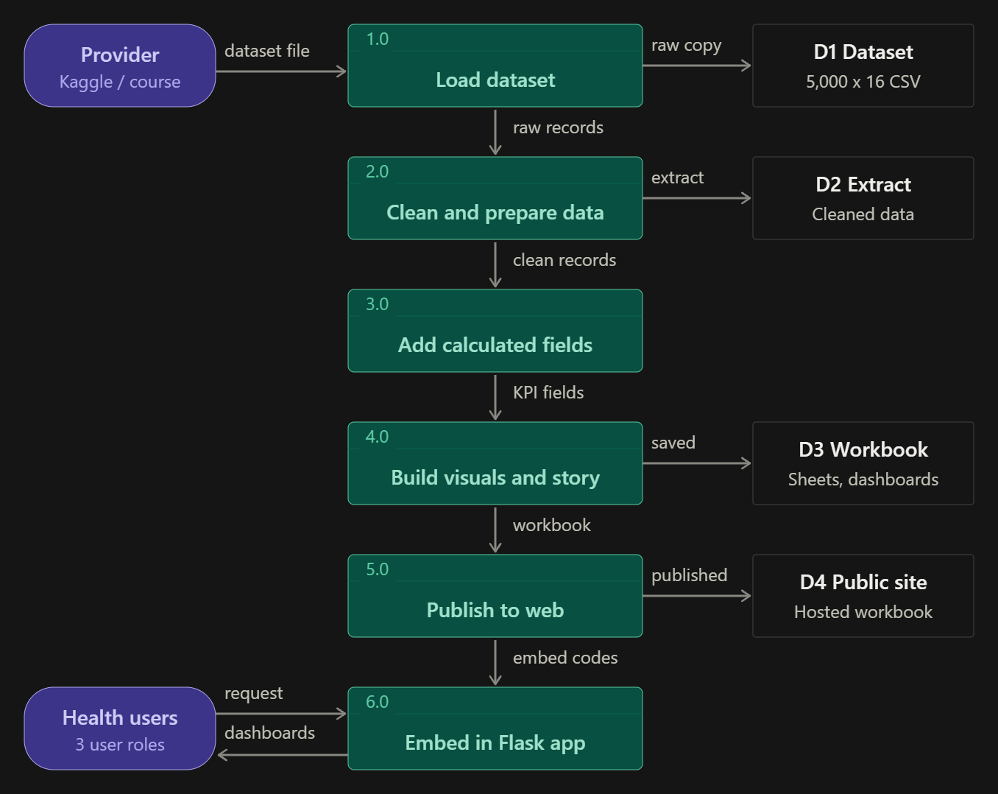Figure 1. DFD
User Stories
Use the below template to list all the user stories for the product.
User Type | Functional Requirement (Epic) | User Story Number | User Story / Task | Acceptance criteria | Priority | Release
Retail Manager (Alice) | Product Performance | USN-1 | As a Retail Manager, I want to analyse product-level sales so that I can identify high-demand products. | The dashboard displays product-level sales and supports filtering by available product and date fields. | High | Sprint-1
Retail Manager (Alice) | Product & Category Analysis | USN-2 | As a Retail Manager, I want to compare product and category performance so that I can identify profitable products and categories. | Sales, profit, and margin are displayed by product and category wherever the required fields are available. | High | Sprint-1
Regional Sales Manager (John) | Store Performance | USN-3 | As a Regional Sales Manager, I want to compare sales, profit, and order volume across stores so that I can identify high- and low-performing locations. | A store-performance view presents sales, profit, and distinct order counts by store and supports comparison across available records. | High | Sprint-1
Regional Sales Manager (John) | Trend Analysis | USN-4 | As a Regional Sales Manager, I want to analyse monthly sales and profit trends so that I can identify changes in performance over time. | A monthly trend view displays sales and profit by month and calculates month-over-month sales growth without division-by-zero errors. | High | Sprint-1
Business Executive (Anthony) | Executive Performance Monitoring | USN-5 | As a Business Executive, I want a consolidated view of sales, profit, and order volume so that I can make informed strategic decisions. | Executive KPIs show sales, profit, and order volume from the governed analytical layer and respond consistently to supported filters. | High | Sprint-1
Business Executive (Anthony) | Customer Segmentation | USN-6 | As a Business Executive, I want to review customer performance by segment, country, and region so that I can understand customer contributions. | The dashboard supports analysis by customer segment, country, and region and displays sales and profit for the selected customer groups. | Medium | Sprint-2
Business Executive (Anthony) | Sales Channel & Payment Analysis | USN-7 | As a Business Executive, I want to compare sales and order volume by sales channel and payment method so that I can understand purchasing patterns. | The channel analytics view groups completed-order sales and distinct orders by sales channel and payment method. | Medium | Sprint-2
Business Executive (Anthony) | Returns & Refund Analysis | USN-8 | As a Business Executive, I want to analyse returned units and refund amounts by product category and return reason so that I can identify return patterns. | The dashboard reports returned units and refund amounts by category and return reason using the available returns data. | High | Sprint-2
Business Executive (Anthony) | Delivery & Shipping Analysis | USN-9 | As a Business Executive, I want to monitor delivery status, on-time delivery, and shipping costs by shipping mode so that I can evaluate delivery performance. | The dashboard summarises delivery status, compares promised and delivered dates where available, and reports shipping costs by shipping mode. | Medium | Sprint-2
Administrator / Data Engineer | Data Quality & Governance | USN-10 | As a Data Engineer, I want to validate null identifiers, duplicate keys, and standardise text fields in staging tables so that downstream analytics use consistent data. | Quality checks identify null key fields and duplicate identifiers; staging transformations trim text and standardise selected labels before modelling. | High | Sprint-1
Administrator / Data Engineer | Data Refresh & Auditability | USN-11 | As an Administrator, I want to monitor data loads and refresh status so that dashboard users can rely on timely analytical data. | Load/refresh status is available for review, and the refresh process can be scheduled or triggered according to the configured environment. | Medium | Sprint-2
Dashboard User | Interactive Dashboard | USN-12 | As a dashboard user, I want to view interactive charts and tables for key retail KPIs so that I can explore business performance without manually combining reports. | The Streamlit dashboard provides store-performance and returns bar charts, a month-over-month line chart, a top-10 customers table sorted by sales, and channel/payment analysis. | High | Sprint-1

